3.7 Tangent Planes and Normal Vectors

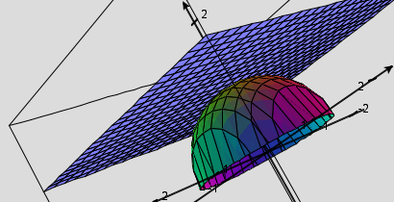
In this section we are interested in how to find the equation of a tangent plane to a surface at some point on the surface.

Motivation: Suppose that is a surface with equation where k is a constant and F has continuous first partial derivatives. Let C be an arbitrary smooth curve that lies on and passes through the point P: .

We know from section 2.1 that the curve C can be given by some continuous vector function . Let be the parameter value such that .

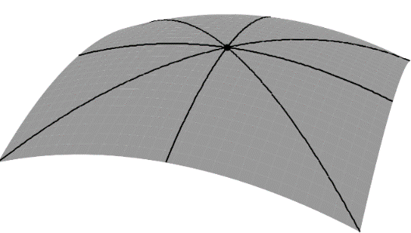
Since C lies on , we know that any point of the form must lie on . Thus, we have that . If we assume that F has continuous first-order partials and we differentiate both sides of this equation we obtain the following by the chain rule:

We can rewrite this equation as . In particular, . So, the gradient vector at P is orthogonal to the tangent vector for ANY smooth curve C on that passes through P. So cannot be the normal vector and must be the binormal vector and points out away from the surface . This observation leads to the following definition.

Note: Since we know that F has continuous first partials we know that , , and are not undefined. This condition can also be shown to imply that the graph of actually does represent a surface, rather than just a collection of random points.

Definition: The tangent plane to the level surface at the point P: (assuming F has continuous first-order partials) is the plane given by the equation: .

Note: In order for the above definition to work we need the gradient to be nonzero at our point of interest. We will say there is no tangent plane when the gradient is the zero vector at our point of interest.
Question: How would the above results change if we were dealing with level curves of the form ?

Answer: The equation would represent a curve in 2-space (for example consider ). Therefore, would be parallel to one of the normal vectors to the curve at any given point. This concept will be important in section 3.9.

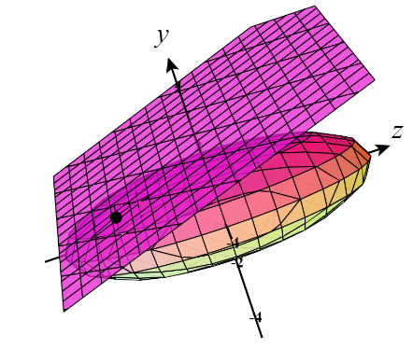
Example 1: Find an equation of the tangent plane at the point to the ellipsoid given by .

Let . We note that , , and . So, by definition, an equation of the desired tangent plane is:
.

Note: In the above example the linear function whose graph is the tangent plane: is called the linearization of f at (-2,1). This function is useful for approximating f near the point (-2,1).

Motivation: Suppose we wish to find a tangent plane to a surface of the form .

Clearly we cannot simply determine the gradient of F because no such function yet exists.

However, if we define F as which of course means that for points on the surface.

Clearly and if we are finding the equation of a tangent plane at the point then by the previous definition we have:

Theorem: Suppose has continuous partial derivatives. An equation of the tangent plane to the surface at the point P: is:

.

Proof: The proof of this theorem is shown in the motivation above.

Note: This definition agrees with the result we obtained at the beginning of this section, however the previous definition was more general. In fact, for most purposes memorizing the above formula is not necessary as we can treat all surfaces of the form like they are surfaces of the form like we did in the previous derivation and example. We note that this is how we actually construct the remaining tangent planes from this section.

Example 2: Find an equation of the tangent plane to surface determined by at the point

We rewrite our equation as and let .
Then we see that . Therefore, .
Therefore we have the equation of the plane given by
We could also express this as .

Note: In the above example the linear function whose graph is the tangent plane: is called the linearization of f at (2,0). This function is useful for approximating f near the point (2,0).

Example 3: Find an equation of the tangent plane to the surface determined by at the point .

We rewrite our equation as and let .
Then we see that . Therefore, .
Therefore we have the equation of the plane given by
We could also express this as .

Note: In the above example the linear function whose graph is the tangent plane: is called the linearization of f at (3,1). This function is useful for approximating f near the point (3,1).
Example 4: Use the tangent plane constructed in Example 3 to estimate the value of at without the use of a calculator.

We can clearly see that at the point we have , however we may not be aware of how to approximate this value without the use of a calculator.
Since we know that the tangent plane will do a good job of approximating the surface near the point we will instead evaluate the tangent plane at the point .

We obtain:

Therefore, we conclude that .

Note: The notion of a tangent plane approximating a surface at a point is similar to how we used tangent lines to approximate curves in Calculus I. However, we can also extend ideas of Taylor series expansions from Calculus II (which allowed us to continue to better approximate curves in 2-spaces) to multivariate Taylor expansions which would allow us to continue to better approximate surfaces in 3-space!

